DENBIGHSHIRE KIDS ARE ALL ART!
Children submit inspirational drawings for competition

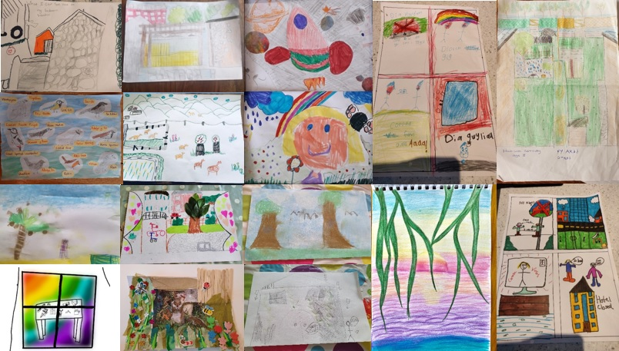

Denbighshire Healthy Schools and Curriculum Enrichment have once again teamed up to help bring children and young people together in Creative Kids Challenges as they live through COVID-19, this time inviting talented young artists to enter an exciting art competition.

Paula Roberts, Denbighshire Healthy Schools Co-ordinator said, “We’ve chose the theme ‘View From My Window’ as our challenge this time because it’s something we’re all doing a lot of at the moment. We invited children and young people to submit any type of art including paintings, sculpture, drawings, and collages and to photograph their artwork. We asked them to tell us what they liked about the view from their window, to give their artwork a title and to tell us how they felt about creating art.”

Judge, Siân Fitzgerald, Denbighshire Community Arts Development Officer said, “Art can be helpful in several ways - it can help us explore our creativity, inspire and make us smile and help us to discover who we really are. It can help us connect with others and stop us feeling lonely when we’re stuck at home. Looking out at the view from a window has something important to teach us - not so much about what we happen to see but how we choose to look at it. I really enjoyed looking at all their views!”

Denbighshire young artists, between the ages of 4 and 14, submitted their artwork creations. The winners of each age category were selected on their creativity and originality and will receive a fun and fantastic complete Drawing, Painting and Colouring Art Kit.

Winners

Up to 7 years
- Flynn Hafwen Edwards, Age 4, Ysgol Llanbedr

7-11 years
- Carmella Mouradi, Year 6, Ysgol Esgob Morgan

12-14 years
- Evaya Hall, Age 12, Myddelton College, Denbigh
