“Let’s make a Movie”

Gweithdy Awduron Ifanc yn dilyn ymweliad Jimmy McGovern o dan arweiniad cwmni elusennol TAPE Community Music and Film

Post-Jimmy McGovern Young Writers’ Workshop with TAPE Community Music and Film

“Os oes gennych stori i’w ddweud, dyma sut i’w ddweud”.
“If you have a story to tell, this is how to tell it”.

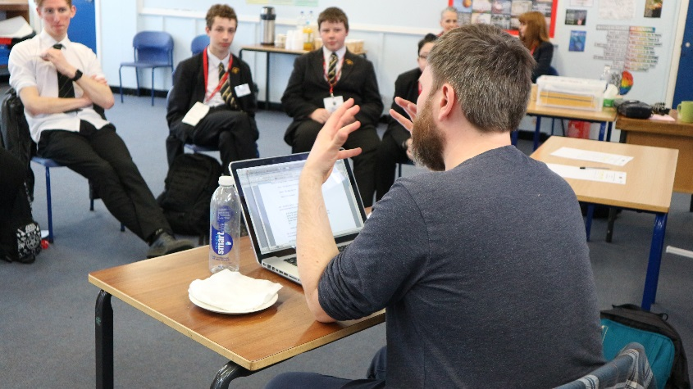

Dyfeisiodd menter Cyfoethogi Cwricwlwm Gwasanaethau Addysg a Gwasanaethau Plant Sir Ddinbych gynllun peilot fis Gorffennaf 2017, o dan yr enw "Let's make a Movie", gan wahodd un o sgriptwyr sgrin mwyaf medrus y DU ym myd ffilm a theledu, sef Jimmy McGovern, i roi dosbarth meistr mewn sgriptio sgrin, yn Ysgol Uwchradd Bendigaid Edward Jones, Y Rhyl (Tachwedd 2017).  Ein prif bartner yn y prosiect peilot yw cwmni elusennol TAPE Community Film and Music. Dydd Mawrth 24 Ebrill 2018, daeth y gwneuthurwr ffilm Andy Turner i arwain disgyblion ysgolion uwchradd ledled Sir Ddinbych i gwrdd â'r her a osodwyd gan Jimmy McGovern, sef sgriptio a gwneud ffilm fer. Nod y Gweithdy Awduron Ifanc oedd gorffen y diwrnod gyda drafft cyntaf o ddrama sgrin wreiddiol.  Gan ddilyn strategaeth awgrymedig Andy ar gyfer ysgrifennu eu ffilm, gwnaeth yr awduron ifanc: -  - Ddatblygu fân syniad ;  - Archwilio'r strwythur;  - Diffinio eu byd, eu cymeriad a'u problem;  - Gweithio allan sut i ddatblygu’r stori (mae “beating” yn hen ddywediad o Hollywood, a ddefnyddir i ddisgrifio'r broses o weithio allan stori); ac yna  - Ysgrifennu drafft cyntaf.  Roedd y cydweithrediad rhwng myfyrwyr a'u mentor, Andy Turner, yn ysbrydoledig a diddorol iawn, gyda'r pwyslais ar gynhwysiad, gan rannu'r broses greadigol o ysgrifennu a chreu stori fer, llawn cymhelliad, ar gyfer y sgrin.  Wrth gyflwyno'r awduron ifanc i'r syniad o "ddrama wedi’i arwain gan bwnc dadleuol", cyflwynodd Andy Turner gymeriadau realistig a pherthnasol iddynt a’u harwain i lunio a chreu stori fer a oedd yn adlewyrchu rhyw agwedd ar fywydau pobl ifanc yn eu harddegau heddiw, er enghraifft , ‘…mae merch yn edrych drwy ei negeseuon text ar ei ffôn…’ - effaith technoleg ar fywydau pobl ifanc.  Diolch Jimmy McGovern, am ysbrydoli’r drafft gyntaf, am alluogi ymgorffori'r angerdd a'r syniadau a ysbrydolodd y rhai a gymerodd ran yn eich dosbarth meistr a gwneud iddynt deimlo’r angen i rannu eu stori gyda chynulleidfa.  Mae ail ddrafft i dilyn, ac yna trydydd. Mae'n debyg, os fydd rhywun, efallai ein cydweithwyr, actorion, gweithredwyr camera, cynhyrchwyr, neu efallai Jimmy McGovern ei hun, yn ei hoffi, yna byddwn yn gallu ei wneud yn ffilm ... ond stori arall yw hynny!... | Denbighshire Education and Children’s Services’ Curriculum Enrichment initiative devised a pilot project in July 2017, called “Let’s make a Movie”, inviting one of the UK’s most accomplished screenwriters in British film and television, Jimmy McGovern, to give a masterclass in screenwriting, at Blessed Edward Jones RC High School, Rhyl (November 2017).  Our chief partner in the pilot project is TAPE Community Film and Music and on Tuesday 24 April 2018, filmmaker Andy Turner, guided secondary students from schools across Denbighshire to meet the challenge laid down by Jimmy McGovern, which is to script and shoot a short film. The goal of the Young Writers’ Workshop was to finish the day with a first draft of an original screenplay.  Following Andy’s suggested strategy for writing their film, the young writers:-  - Developed a small idea;  - Explored the structure;  - Defined their world, character and problem;  - Beat it out (“Beating” is an old Hollywood term, used to describe the process of working out the storyline); and  - Wrote the first draft.  The collaboration between students and their mentor, Andy Turner, was profoundly inspiring and engaging, with its emphasis on inclusion, sharing the creative process of writing and crafting a compelling short story for the screen.  Introducing the young writers to the idea of “issue-led drama”, Andy Turner skilfully acquainted them with real, relatable and relevant characters and guided them to shape and craft a short story that reflected some aspect of the lives of teenagers today, for example, ‘…a girl scrolls her texts...’ - the impact of technology on the lives of young people.  Thanks Jimmy McGovern, first draft penned, embodying the passion and ideas that inspired those who took part in your masterclass and who feel compelled to share their story with an audience.  Second draft to follow, then third. Chances are someone, whether it’s our collaborators, actors, camera operators, producers, even Jimmy McGovern himself, will like it, then we’ll be able to make it… but that’s another story!...
