Denbighshire Creative Kids Challenges
Easy, fun and creative activities for Kids to Get Through COVID-19

The second of our exciting Denbighshire Creative Kids Challenges launches today, whether you’re at home or at school in Denbighshire. Entry will be in three age categories - up to 7 years, 7 to 11 years and 12-14 years.

As part of the current drive to help keep people connected and to overcome some of the barriers caused by social distancing and self-isolation, Denbighshire Healthy Schools and Curriculum Enrichment Initiative are inviting children and young people to capture hopeful messages and images to their own design, suitable for a T-shirt. It’s a way of connecting with others when most of our time is being spent alone and at home. We want you to still feel connected with each other in this ‘new normal’ way of life and what you can tell us about people being strong, kind and good even in difficult times.

Challenge Number Two - Design a T-shirt
“DAW ETO HAUL AR FRYN”… / “THE SUN WILL SHINE AGAIN”…
- connecting Denbighshire children and young people with hopeful messages

Get your colouring pens out! You have 7 days to design a T-shirt on the template provided, displaying inspiring words in Welsh or English or both, pictures, patterns, logos, etc, etc, for everyone during COVID-19, which shows off your style and personality. Here are some examples to help you:-

“Together.”
“Tough times never last... but tough people do.”
“This too shall pass”
“Waiting with you”
“Never doubt the capacity of the human spirit”
“Soon we will be together. Stay home + have hope”

Send you entry to us via e-mail - sarah.dixon@denbighshire.gov.uk by 5pm on Monday 11 May 2020.

4 easy steps to follow:-
- Print off the T-shirt template provided or simply draw your own;
- Draw and colour your T-shirt design;
- Photograph your T-shirt design;
- Email your T-shirt design to us in which ever format suits you.

Your entries will be judged by members of the Creative Team.

Winners will be announced via Twitter @cyfoeth_enrich on Friday 15 May 2020.

Prizes: The winner of each age category will have his/her T-shirt made to their design.

For further details, please contact Paula Roberts, Healthy Schools Co-ordinator - paula.roberts@denbighshire.gov.uk / 01824 712059

PLEASE NOTE: Unless otherwise instructed, it is assumed that permission will be kindly given to publish prize-winners’ names. Please tick the box to agree 
“DAW ETO HAUL AR FRYN”
“THE SUN WILL SHINE AGAIN”
T-shirt TEMPLATE
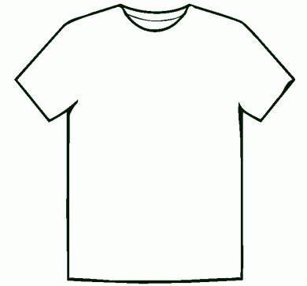

Name: _______________________________________ Year: ____________________

School: ______________________________________________________________________

Please design your T-shirt, in colour, on the template provided. Email your entry to sarah.dixon@denbighsire.gov.uk by 11 May 2020.
PLEASE NOTE: Unless otherwise instructed, it is assumed that permission will be kindly given to publish prize-winners’ names.
Please tick the box to agree 

