SOS Garddio yn Ysgol Tremeirchion
Ysgol yn galw am bobl i ymuno â’r gâd ac yn croesawu cyfeillion, teulu a gwirfoddolwyr i helpu trawsnewid gofod tu allan

6 Chwefror 2017

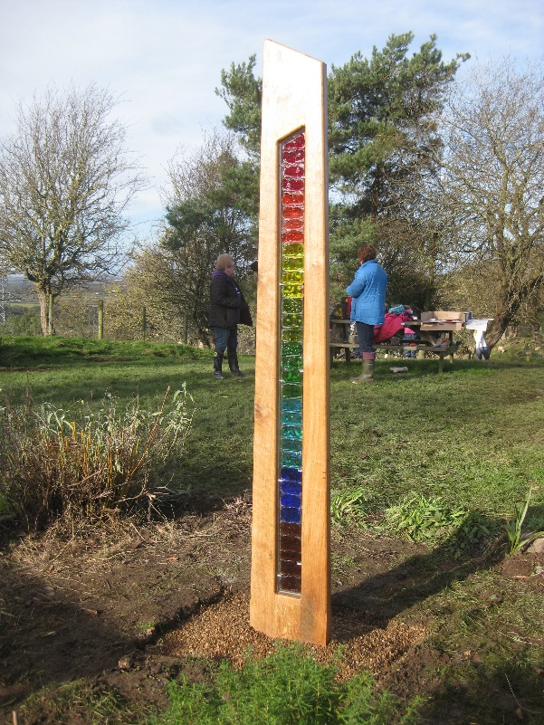
Am ffordd wych i wario bore oer, heulog o Wanwyn ym Mis Chwefror 2017 gyda thîm o wirfoddolwyr garddio brwdfrydig, gan gynnwys plant, staff, rhieni a neiniau a theidiau wrth dacluso gofod tu allan yn Ysgol Tremeirchion ger Llanelwy.

Nid gwaith hawdd oedd hi.’Roedd yr ardd wedi cael ei adael i fynd yn angof a blêr. Serch hynny ’roedd gan Ysgol Tremeirchion gynllun i drawsnewid a rhoi bywyd newydd i mewn i’r gofod tu allan hwn. Erbyn canol y prynhawn, ’roedd criw o helpwyr wedi llwyddo i gwblhau ‘rhan un’ o’r her a welodd sefydlu cerflun gwydr a choed odidog i ddathlu 50 mlynedd o addysg yn yr ysgol.

Fis Mai 2016, comisiynwyd Hilary a Graham Roberts, artistiaid o Gymru, i ddylunio a gwneud cerflun gyfoes i ddathlu’r penblwydd arbennig hwn. Datblygwyd y cynllun ar gyfer y cerflun yn ystod gweithdy celf un-dydd oedd yn cynnwys y disgyblion i gyd a’r staff fis Gorffennaf 2016, drwy weithio gyda gwydr ac acrilig.

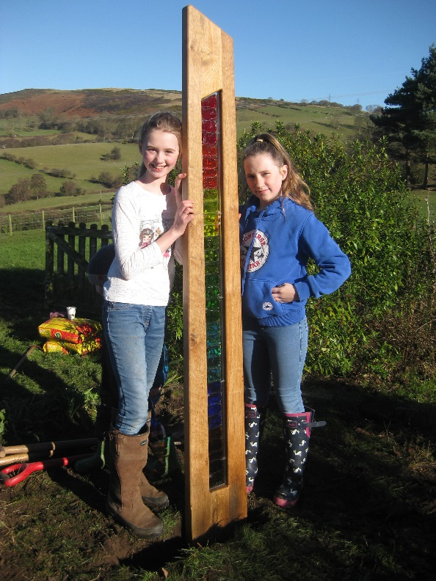
Yn dilyn brwydr di-flino mewn heulwen llachar, ’roedd gwaith y criw o helpwyr yn gyflawn gan adael y darn tir wedi ei drawsnewid, a’r cerflun newydd yn ei le.

Mae Ysgol Tremeirchion yn edrych ymlaen yn awr i ‘ran dau’ o’r her o drawsnewid y gofod tu allan.

Garden SOS at Ysgol Tremeirchion
School issues a call to arms and recruits friends, family and volunteers to help transform outdoor space

February 6 2017

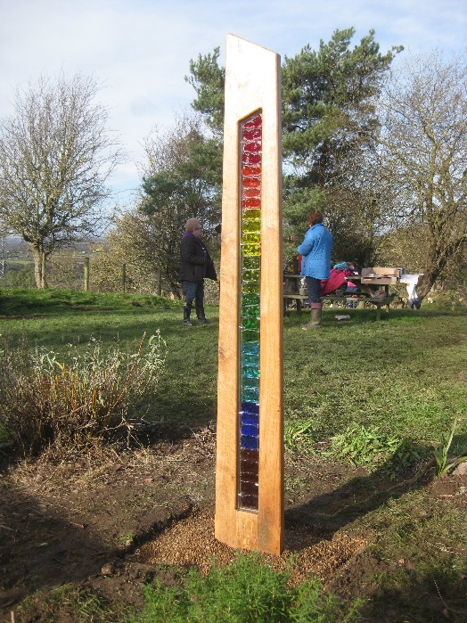
What a brilliant way to spend a crisp, sunny, Spring Saturday morning in February 2017 with a team of enthusiastic gardening volunteers, including children, staff, parents and grandparents, clearing the outdoor space at Ysgol Tremeirchion, near St Asaph.

This was no easy task. The garden had become overgrown and neglected. Nevertheless, Ysgol Tremeirchion had a plan to transform and breathe new life into the outdoor space. By mid-afternoon, the team of helpers had successfully completed ‘phase one’ of the challenge, which saw the installation of an elegant, hand-crafted glass and wood sculpture, to commemorate 150 years of education at the school.

In May 2016, professional Welsh artists, Hilary and Graham Roberts, were commissioned by the school to design and make a contemporary sculpture to celebrate the school’s landmark anniversary. The design for the sculpture was developed during a one day arts workshop involving all pupils and staff in July 2016, working with glass and acrylics.

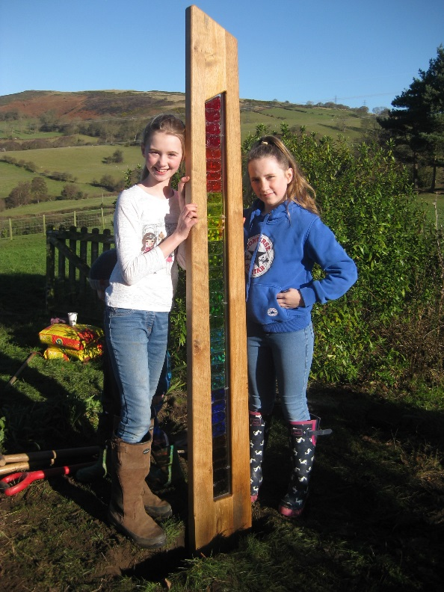
After a tireless struggle in brilliant sunshine, the team’s hard work was complete and the challenging patch transformed, with the sculpture newly installed.

Ysgol Tremeirchion now looks forward to ‘phase two’ of its exciting outdoor space makeover challenge.

