Hyfforddiant Drama Epig 'Ysblenydd’ yn wir!  Gweithdy yn seiliedig ar theatr Brecht  Ysgol Dinas Brân, 29/06/2018  Pan gysylltodd Pennaeth Drama Ysgol Dinas Brân â mi yn ddiweddar, yn chwilio am ymarferydd i gynnal gweithdy gyda myfyrwyr TGAU ar Brecht a dyfeisio technegau, mae'n rhaid i mi gyfaddef mai hwn oedd un o'r heriau anoddaf yr wyf wedi cael fy ngosod yn ddiweddar. Fodd bynnag, byth yn un i roi'r gorau iddi ar y rhwystr cyntaf, roeddwn wrth fy modd i dderbyn ateb gan David Barnett, Athro Theatr ym Mhrifysgol Efrog, gan gyflwyno mi a’r ysgol i Kerry Frampton, Cyfarwyddwr Artistig, Splendid Productions - un o'r ymarferyddion mwyaf blaenllaw a chreadigol ar waith Brecht sy'n gweithredu yn y maes heddiw.  Roedd Bertolt Brecht yn gyfarwyddwr a dramodydd Almaeneg ac mae'n adnabyddus am ei ymagwedd wleidyddol at theatr. Wedi ei gael yn rhwystredig â theatr naturiol ei gyfnod, gwnaeth Brecht ddeffro ei gynulleidfa gyda dyfeisiau dieithrio a symudodd y wal rhwng actor a chynulleidfa. Mae ei dechnegau'n dal i gael eu defnyddio yn y theatr ac maent yr un mor berthnasol a newydd heddiw ag yr oeddent pan gawsant eu cyflwyno gyntaf.  Mae Splendid Productions yn creu theatr wleidyddol broffesiynol o safon uchel gyda gweithdai ymarferol sy'n seiliedig ar theori ar gyfer bobl ifanc ledled y DU. Mae eu harbenigedd yn dod â thechneg Brechtian yn fyw i fyfyrwyr, mewn perfformiad a thrwy ddarparu profiad gweithdy iddyn nhw ei archwilio drostynt eu hunain.  Roedd y gweithdy 3 awr dan arweiniad Kerry Frampton yn brofiad theatrig gwirioneddol anhygoel ac yn ffordd wych i fyfyrwyr ddarganfod technegau theatrig Brecht mewn ffordd hygyrch, ysbrydoledig, angerddol, meddylgar a chreadigol. Yn gryno a llawn gwybodaeth, egni a sgil, fe wnaeth Ms Frampton gysylltiad â'r myfyrwyr ifanc ac gyda hwy, er mwyn iddynt fedru archwilio technegau Brecht a datblygu'r theori drostynt eu hunain.  Buaswn yn argymell Kerry Frampton a Splendid Productions i bawb - roedd y gweithdy'n ysbrydoledig ac yn rhoi profiad bythgofiadwy i'r myfyrwyr (a minnau). | 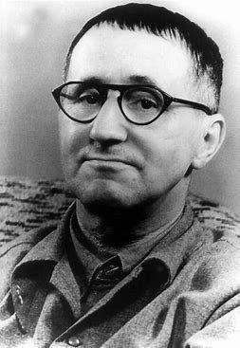  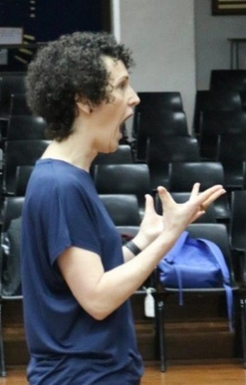  Bertolt Brecht  Kerry Frampton  Kerry Frampton - inspiring | ‘Splendid’ Epic Drama Tuition Indeed!  Workshop based of the theatre of Brecht  Ysgol Dinas Brân, 29/06/2018  When the Head of Drama at Ysgol Dinas Brân contacted me recently, seeking a practitioner to conduct a workshop with GCSE students on Brecht and devising techniques, I have to admit that this was by far one of the toughest challenges I have been set in recent times. However, never one to give up at the first hurdle, I was delighted to receive a reply from David Barnett, Professor of Theatre at the University of York, introducing me and the school to Kerry Frampton, Artistic Director at Splendid Productions – arguably, one of the best, most creative Brecht practitioner working today.  Bertolt Brecht was a German director and playwright and is well-known for his political approach to theatre. Frustrated with the naturalistic theatre of his time, Brecht woke up his audience with alienation devices and removed the wall between actor and audience. His techniques are still used in theatre and are just as relevant and ground-breaking today as they were when they were first introduced.  Splendid Productions create high quality professional, political theatre with theory-based practical workshops for young people across the UK. Their speciality is bringing Brechtian technique to life for students, both in performance and by providing a workshop experience for them to explore it for themselves.  The 3 hour workshop led by Kerry Frampton was a truly amazing theatrical experience and a great way for students to discover Brechtian theatrical techniques in an accessible, inspiring, passionate, thoughtful and creative way. Fast paced and informative, full of energy and skill, Ms Frampton enthralled and engaged with her young audience, quickly getting them to their feet to explore the techniques of Brecht and develop the theory for themselves.  I would recommend Kerry Frampton and Splendid Productions to everyone – the workshop was truly inspiring and gave the students (and me) an unforgettable experience.

